**Challenges in Implementing Data Analytics in Small Scale Enterprises**

**A Project Work Report**

*Submitted in the partial fulfillment for the award of the degree of*

**BACHELOR OF ENGINEERING**

**IN**

**COMPUTER SCIENCE WITH SPECIALIZATION IN**

**ARTIFICIAL INTELLIGENCE AND MACHINE LEARNING**

**Submitted by:**

SNEHA KUMARI - 21BCS5019

PAIDI HEMANTHI NAIDU – 21BCS5239

**Under the Supervision of:**

**Dr. Priyanka Kaushik**



**CHANDIGARH UNIVERSITY, GHARUAN, MOHALI - 140413,**

**PUNJAB**

**November, 2024**

# Abstract

In the past few years, the domain of Data Analytics has grown in many fields, including medical, financial areas, marketing, military, supply chain management, big businesses, startups, etc. Now, to run a business, one cannot imagine to grow it without the help of Data analytics.

There are numerous advantages of data science and the advancement in this field is still going on. But, even though the ongoing progress in the data science and analytics field, there are very few number of individuals who know how to use them. This is one of the main causes of not using the data analytics to its full potential. These algorithms are needed to be developed in a way such that even a small scale enterprise can use it without facing any problem.

Even after the technological advancement, the user base of this field is low due to lack of understanding. Every business needs data analytics to operate smoothly, earn maximum profits and save much of their time.

Big enterprises use data analytics in their business but it will still take over a decade to make Small Scale Enterprise owners understand and use data analytics in their business. Lack of guidance, lack of knowledge in this field, habituated to traditional method of using data, failure of adoption of new technology, lack of resources, privacy and security concerns, data quality issues, etc. are the main causes that makes Small Scale Enterprise owners avoid the use of data analytics.

Keywords: Data analytics, Enterprises, Challenges, frameworks, Data Quality

# Table of Contents

|  |  |
| --- | --- |
| Title Page | i |
| Abstract | ii |
| 1.    Introduction |  |
| 1.1           Problem Definition |  |
| 1.2 Project Overview |  |
| 1.3 Hardware Specification |  |
| 1.4 Software Specification |  |
| 2.    Literature Survey |  |
| 2.1 Existing System |  |
| 2.2 Proposed System |  |
| 2.3 Literature Review Summary |  |
| 3.    Problem Formulation |  |
| 4.    Research Objective |  |
| 5.    Methodologies |  |
| 6.    Experimental Setup |  |
| 7.    Conclusion |  |
| 8.    Tentative Chapter Plan for the proposed work |  |
| 9.    Reference |  |

# INTRODUCTION

The purpose of this study paper is to examine the difficulties that small-scale enterprises face when it comes to data analytics. We can find probable answers and tactics to assist small organisations in utilising data to their benefit by comprehending these difficulties. The study will examine a number of data analytics topics, such as organisational and cultural influences on data uptake as well as data administration, analysis, and interpretation.

Large businesses have embraced the practice of making decisions based on data, while small businesses frequently find it difficult to fully utilise their data. Number of factors come together to cause this discrepancy, such as organisational culture, technical proficiency, and resource constraints.

Due to their smaller size and tighter finances, small-scale enterprises have to face difficulties when it comes to applying efficient data analytics strategies.

The above challenges may make it even harder for them to make wise judgements, increase productivity, and maintain competitiveness.

This research aims to offer a thorough understanding of the data analytics difficulties faced by small-scale enterprises using a combination of case studies and literature evaluation. Providing small businesses with the skills and resources they need to overcome these obstacles and get the value from their data is the ultimate aim.

Although﻿existing﻿literature﻿illustrate﻿a﻿linear﻿relationship﻿between﻿data﻿analytics﻿and﻿SME﻿ performance﻿(O’Connor﻿&﻿Kelly,﻿2017).﻿But﻿still,﻿lack﻿of﻿data﻿integration,﻿poor﻿IT﻿infrastructure,﻿ low﻿technology﻿adoption﻿and﻿shortage﻿of﻿analytics﻿knowledge,﻿leads﻿to﻿ineffective﻿execution﻿of﻿data﻿ analytics﻿in﻿SME﻿(Ajibade,﻿et.al,﻿2019;﻿Lyver﻿&﻿Lu,﻿2018).﻿With﻿a﻿mix﻿blend﻿of﻿thoroughly﻿examined﻿ studies﻿over﻿last﻿decade,﻿one﻿set﻿of﻿studies﻿have﻿been﻿largely﻿reviewed﻿that﻿offers﻿opportunities﻿to﻿move﻿ forward﻿and﻿reflect﻿backward﻿whereas﻿another﻿set﻿of﻿studies﻿are﻿unattended.﻿Therefore,﻿a﻿rigorous﻿ systematic﻿review﻿will﻿not﻿only﻿integrate﻿the﻿scattered﻿research﻿studies﻿but﻿also﻿draw﻿attention﻿of﻿ not-so﻿known﻿research﻿themes﻿in﻿this﻿domain.﻿It﻿will﻿complement﻿the﻿existing﻿studies﻿and﻿bring﻿ the﻿loose﻿ends﻿together.﻿Moreover,﻿an﻿exclusive﻿systematic﻿review﻿on﻿data﻿analytics﻿in﻿SME﻿will﻿ provide﻿a﻿theoretical﻿background﻿for﻿future﻿research,﻿answer﻿many﻿unaddressed﻿questions﻿by﻿deeper﻿ understanding﻿on﻿the﻿matter,﻿and﻿expand﻿the﻿broad﻿topics﻿of﻿research﻿studies﻿in﻿the﻿research﻿domain.

## Problem Definition

* Small businesses often operate on tight budgets, which limits their ability to invest in advanced analytics tools, technologies, and skilled personnel.
* Many small businesses lack in-house expertise in data analytics, making it difficult to implement, manage, and interpret analytics solutions.
* Small businesses may struggle with collecting and maintaining high-quality, relevant data due to inadequate data management systems.
* Organizational resistance, often due to a lack of understanding or fear of new technologies, can impede the adoption of data analytics.
* Small businesses may be skeptical about the ROI from data analytics investments, particularly when immediate results are not apparent.

## 1.2 Problem Overview

## 1.3 Hardware Specification

## 1.4 Software Specification

# LITERATURE SURVEY

## 2.1 Existing System

1.What are the Adoption and Grasping Issues?

SMEs frequently struggle to incorporate data analytics into decision-making and are unaware of its advantages. The necessity of decision support tools for SMEs is emphasised by Kolkman et al. (2019), but adoption is hampered by organisational culture, technological preparedness, and budgetary constraints, according to Justy et al. (2023).

2. How the Resource and Cost Restraints?

Implementing data analytics in SMEs is significantly hampered by high costs and resource constraints. Coleman et al. (2016) and Falahat et al. (2023) talk about how many SMEs are discouraged by their limited resources and the difficulty of managing their data. Working together with outside partners is suggested as a remedy.

3. Issues encountered with Technology and Data Quality:

SMEs may lack the IT infrastructure required to handle massive datasets. Bianchini and Michalkova et al. (2019) and Ogbuokiri in et al. (2015) point out that problems with data quality and technology limitations make it difficult to employ data analytics effectively.

4. Identifying the Training and the Skills Gap.

One recurring obstacle is the absence of internal expertise. To overcome this obstacle and promote a data-driven culture, Willetts et al. (2023) and Tawil et al. (2023) stress the need of skill development and cooperation with educational institutions.

5. Opposition to Change

Data adoption frequently faces pushback from within organisations. Su (2017) points out that SMEs consider data analytics to be unduly complicated, but Cadden et al. (2023) contend that getting past this mentality fosters innovation and gives businesses a competitive edge.

6. Implementation Frameworks

Many frameworks have been put forth to assist SMEs in putting data analytics into practice. An evaluation framework is provided by Baijens (2019), and Iteration Insights (2021) promotes an incremental strategy that focusses on small-scale use cases in order to progressively develop skills.

Adopting data analytics presents SMEs with a number of hurdles, including organisational, technological, financial, and skill-related. Frameworks, decision aids, and steady scaling, however, can assist SMEs in realising the growth and innovation potential of data analytics.

## 2.2 Proposed System

## 2.3 Literature Review Summary (Minimum 7 articles should refer)

|  |  |  |  |  |  |
| --- | --- | --- | --- | --- | --- |
| **Year and**  **Citation** | **Article/ Author** | **Tools/ Software** | **Technique** | **Source** | **Evaluation Parameter** |
|  |  |  |  |  |  |
|  |  |  |  |  |  |
|  |  |  |  |  |  |

.

# 3. PROBLEM FORMULATION

The main challenges faced by SMEs owners are listed below:-

1. Insufficient Data Structure

* Lack of Storage: SMEs lack the storage capacity required to add, update and accommodate the dataset.
* Data Fragmentation: Data is often scattered across different department and systems making it tough to clean and analyze.
* Legacy systems: Using outdated hardware and software can slower down the process of data collection, storage, access, retrieval and management.

Example: A Small Scale Enterprise may struggle to store customer details due to lack of hardware and software capabilities making the data analysis process difficult

1. Data Validity Issue

* Data Inconsistency: Data may be collected in different formats, making it difficult to analyze.
* Data Inaccuracy: Incomplete or missing values in the data can lead to bias results.
* Data entry error: Human error during the data entry process can give misleading results.

Example: An ecommerce company may encounter data quality issues if the address of the customers is entered incorrectly, leading to shipping errors and customer dissatisfaction. Accuracy in the data is necessary to ensure smooth processing, logistics and better customer experience.

1. Data Safeguarding Challenges

* Following regulations: The SMEs must follow the data privacy regulations such as the GDPR and CCPA.
* Data breach threat: The risk of data breach and threat can damage the SME’s reputation and break the customer’s trust with the company.
* Handling Sensitive Data: Handling and safeguarding the customer’s data requires robust security measures.

Example: The patient’s data in the hospital must be protected and prevented from unauthorized access. Failure to which can result in hefty fines and damage to the company’s reputation.

1. Challenges in Data Analysis and Interpretation

* Limited Expertise in Data analytics: Limited workforce in the SME.
* Lack of skilled employee: SMEs may struggle to find and retain data analysts with the required skills.
* Organizational strengths: Existing employees may not have the desired domain knowledge to effectively analyze the data.

Example: A local manufacturing company may struggle with the supply chain if the internal team lacks to effectively analyze the inventory and logistics data, resulting in increased operational costs.

1. Trouble in identifying the relevant data

* Data flooding: SMEs may struggle with the abundancy of available data and find it tough to identify the most relevant information.
* Data relevancy: SMEs can find it challenging to identify the most relevant data.

Example: A small enterprise in the retail sector might collect the customer data, such as transactions, payment mode, customer preference, product ordered and in what quantity. However, without a data strategy and analytical tool, the SME might find it difficult to understand the customer needs and may fail in retaining its customers.

1. Scarcity of Tools and Resources

* Funding limitation: SMEs have small budgets and limited funding due to its small scale. Thus, limited budget for data analysis tools and resources.
* Technical Restrictions: Some tools may be too complex and require specialized knowledge in the domain to use them.
* Hardware Constraints: Some Business analytics tools may require specialized hardware.

Example: SMEs may not able to cover the expense of a data analysis software or may lack the necessary computation power to run the complex models.

1. Obstacles in Executing Data-Driven Strategies

* Organizational Culture: Some SMEs use traditional approach for decision making that relies heavily on experience rather than data.
* Fear of failure: Employees are hesitant to adopt data-driven strategies for decision-making due to fear of failure.
* Reluctance to change: Employees are reluctant to adopt and learn new data analytics methods.

Example: A small manufacturing firm still relies on the experience and intuition of its long serving staff for production planning. Employees fear that the data driven approach may highlight their inefficiencies or mistakes which can risk their job security.

# 4. OBJECTIVES

The primary objective of integrating data analytics in small businesses is :-

* To leverage data-driven insights to enhance decision-making
* Optimize operations
* Improve customer experiences
* Drive business growth

By utilizing data analytics, small businesses can :-

* Gain a competitive edge
* Identify new opportunities
* Respond more effectively to market changes.

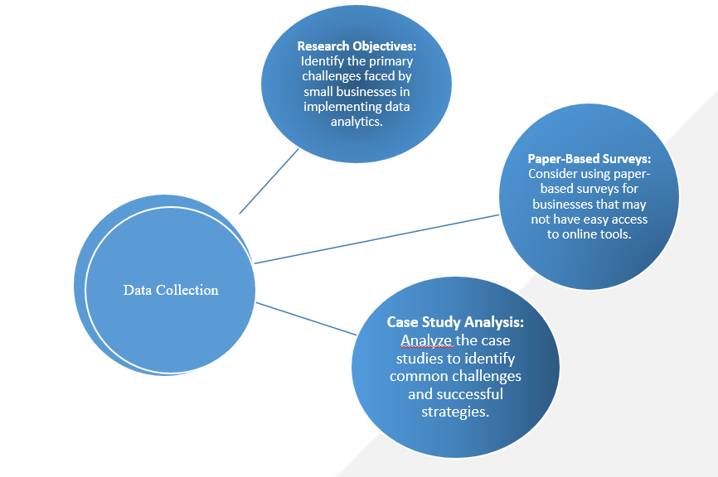

# 5. METHODOLOGY

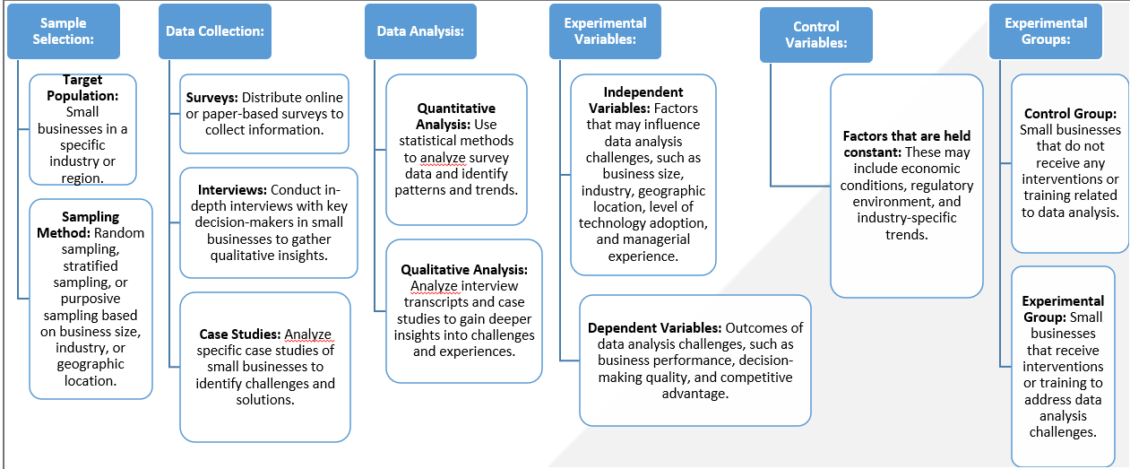

We did a thorough examination of 45 data sets, using project outcomes, field notes, focus group talks, and student correspondence. We recognised and recorded obstacles for every project, along with their resolutions, the project's current state of completion, and contributing elements. We identified issues that could have been foreseen and addressed before the project started by conducting a cooperative thematic analysis.

# 6.EXPERIMENTAL SETUP

According to our research, small and medium-sized businesses (SMEs) encounter many challenges when attempting to use data analytics to boost operations and expand their businesses. These issues are varied and fall into a number of important categories, each of which poses particular hurdles that impede SMEs from successfully implementing data-driven initiatives.

Our research into the problems that SMEs encounter when it comes to data analysis has shown a number of tools that are used by both large-scale organisations and SMEs at various phases of the data collection, analysis and implementation. Even while these tools frequently overlap, they might each have unique qualities that are suited to the unique requirements and available resources of a certain organisational type.

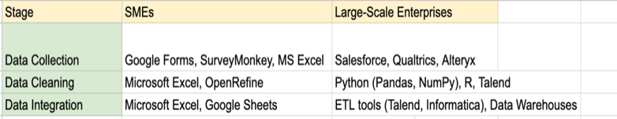

This image depicts the tools used for data collection.

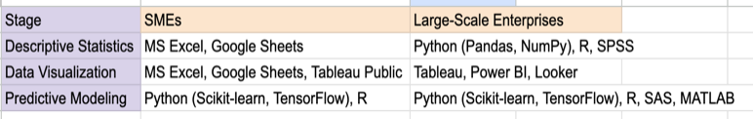

This image depicts the tools used for data analysis

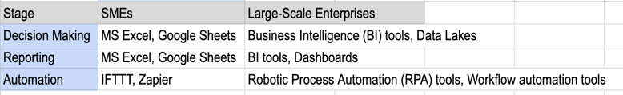

This image depicts the tools used for data implementation.

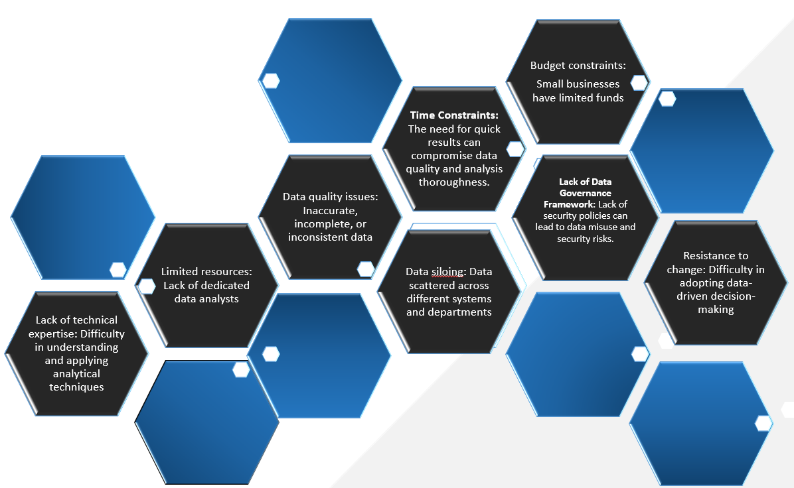

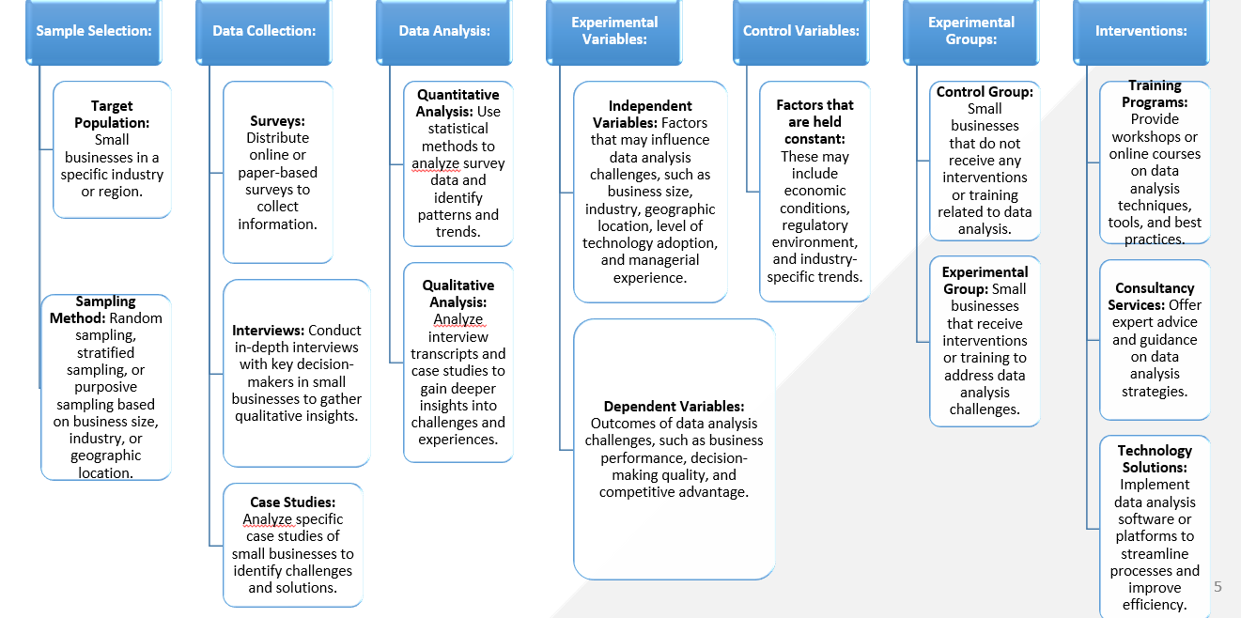

# 7.CONCLUSION

## 8. TENTATIVE CHAPTER PLAN FOR THE PROPOSED WORK

**CHAPTER 1: INTRODUCTION**

* Small businesses, despite their resource constraints, can benefit significantly from leveraging data-driven insights.
* Enables businesses to make informed decisions, optimize processes, and identify growth opportunities.
* For small businesses, data analytics can level the playing field by providing actionable insights that lead to better outcomes.
* Helps small business owners make informed choices based on data rather than intuition.

**CHAPTER 2: LITERATURE REVIEW**

**CHAPTER 3: OBJECTIVE**

The primary objective of integrating data analytics in small businesses is :-

* To leverage data-driven insights to enhance decision-making
* Optimize operations
* Improve customer experiences
* Drive business growth

By utilizing data analytics, small businesses can :-

* Gain a competitive edge
* Identify new opportunities

Respond more effectively to market changes

**CHAPTER 4: METHODOLOGIES**

We did a thorough examination of 45 data sets, using project outcomes, field notes, focus group talks, and student correspondence. We recognised and recorded obstacles for every project, along with their resolutions, the project's current state of completion, and contributing elements. We identified issues that could have been foreseen and addressed before the project started by conducting a cooperative thematic analysis.

**CHAPTER 5: EXPERIMENTAL SETUP**

Our research into the problems that SMEs encounter when it comes to data analysis has shown a number of tools that are used by both large-scale organisations and SMEs at various phases of the data collection, analysis and implementation. Even while these tools frequently overlap, they might each have unique qualities that are suited to the unique requirements and available resources of a certain organisational type.

**CHAPTER 6: CONCLUSION AND FUTURE SCOPE**

The future of data analytics in small businesses is promising, with opportunities to leverage emerging technologies, enhance decision-making, and improve competitiveness. By staying ahead of these trends and focusing on continuous learning and adaptation, small businesses can fully realize the benefits of data analytics in the years to come.

**FUTURESCOPE**

1. **Integration of Artificial Intelligence and Machine Learning :** Small businesses will be able to leverage AI/ML for predictive analytics, personalized marketing, customer behavior analysis, and operational efficiency, allowing them to compete with larger enterprises.
2. **Enhanced Data Security and Privacy :** Ensuring that small businesses can manage and analyze data without compromising sensitive information.
3. **Real-Time Data Analytics :** Small businesses will gain access to real-time data analytics platforms that can process and analyze data instantaneously, allowing for more agile responses to market changes, customer needs, and operational challenges.
4. **Customized Analytics Solutions :** The future will see the rise of highly customizable analytics platforms tailored to the unique requirements of different sectors, such as retail, healthcare, or manufacturing, providing more relevant insights and actionable strategies.
5. **Integration with IoT and Other Emerging Technologies :** Small businesses will increasingly integrate data analytics with IoT devices, enabling smarter inventory management, predictive maintenance, and enhanced customer experiences.
6. **Sustainable and Ethical Data Practices :** Small businesses will use data analytics to optimize resource usage, reduce waste, and ensure ethical practices throughout their operations, contributing to their social and environmental responsibilities.

## REFERENCES

1. Kolkman, D.A., et al., "Challenges to data science projects with SMEs: An analysis and decision support tool," 2019.
2. Justy, T., et al., "On the edge of big data: Drivers and barriers to data analytics adoption in SMEs," 2023.
3. Coleman, S., et al., "How can SMEs benefit from big data? Challenges and a path forward," 2016.
4. Falahat, M., et al., "Big data analytics capability ecosystem model for SMEs," Sustainability, 2023.
5. Ogbuokiri, B.O., Udanor, C., Agu, M., "Implementing big data analytics for small and medium enterprise (SME) regional growth," University of Nigeria, November 2015.
6. Bianchini, M., Michalkova, V., "Data analytics in SMEs," OECD SME and Entrepreneurship Papers, June 2019.
7. Willetts, M., Atkins, A.S., Stanier, C., "Barriers to SMEs adoption of big data analytics for competitive advantage," Staffordshire University, 2023.
8. Tawil, A.R., Mohamed, M., Schmoor, X., Vlachos, K.,  Haidar, D., "Trends and challenges towards effective data driven decision making in UK SMEs: Case studies and lessons learnt from the analysis of 85 SMEs," arXiv.

May 2023.

1. Su, B., "5 key factors holding small businesses back from joining the 'data revolution'," Analytics for Humans, 2017
2. Cadden, T., et al., "Examining the role of big data and marketing analytics in SMEs innovation and competitive advantage: A knowledge integration perspective," Journal of Business Research, November 2023.
3. Baijens, J., "An assessment framework for data analytics capabilities in SMEs," 2019.
4. Iteration Insights, "A practical SME approach for your data strategy," Governance, July 2021.
5. Barocas, S., & Selbst, A. (2016). Big data’s disparate impact. California Law Review.
6. Bulger, M., Taylor, G., & Schroeder, R. (2014). Data-driven business models: Challenges and opportunities of  big data. Report by the Oxford Internet Institute.
7. Cavanillas, J. M., Curry, E., & Wahlster, W. (2016). New horizons for a data-driven economy. Springer, New York.
8. Cukier, K., & MayerSchoenberger, V. (2013). The rise of big data: How it’s changing the way we think about the  world. Foreign Affairs 92 (28).
9. Delden, H. v. (2011). A methodology for the design and development of integrated models for policy support. Environmental Modelling Software 26(3).
10. Diez, E., & Mcintosh,  B. (2011).  Organizational drivers for, constraints on and impacts of decision and informationsupport tool use in desertification policy and management. Environmental Modelling Software 26(3).
11. Floridi, L., & Taddeo, M. (2016). What is data ethics?  Philosophical Transactions of the Royal Society A: Mathematical, Physical and Engineering Sciences 374(1).
12. Happe, K., & Ballman, A. (2008). Doing policy in the lab. Options for the future use of model-based policy analysis for complex decision-making. Proceedings of the 107th EAAE Seminar.